Abstract template for MD-GAS 2020
A. One^{(a)}, B. Two^{(b)}, C. Three^{(a)}
^{(a)} Normandie Université, ENSICAEN, UNICAEN, CEA, CNRS, CIMAP, 14000 Caen
^{(b)} Departamento de Química - Módulo 13 - Universidad Autónoma de Madrid -28049 Madrid - Spain
This is a sample abstract for EPIC-MAN 2019. Abstracts must be received by Friday January 31st 2020. They must be electronically submitted through the MD-GAS 2020 webpage md-gas.sciencesconf.org. Only abstracts with at least one MD-GAS 2020 participant will be included in the Book of Abstracts.
Abstracts should be written in English. Templates for Microsoft Office Word and OpenOffice are available on the MD-GAS 2020 webpage.
Abstracts must contain a title, the authors’ list and their affiliations. Among the authors, the corresponding author, attending MD-GAS 2020, should be underlined. The total abstract length should not exceed one A4 page, including figures and tables; the text length might be less than 2000 characters (spaces included). We encourage authors to include a figure (graphical abstract). The following figure formats are acceptable: jpeg, png, gif, eps, pdf. References in the text must be given by numbers in square brackets [1]. The list of references is placed at the end of the abstract text.
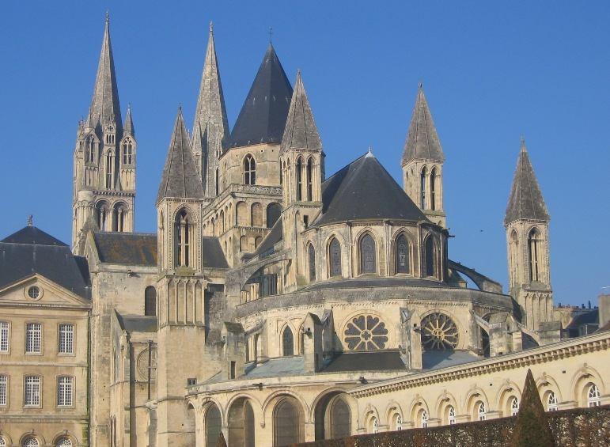
Figure 1: Saint Etienne Church at Abbaye aux Hommes in Caen.
 | Title | Authors names | Affiliations | e-mail | Body text | Captions | Ref.
Size | 14 pt | 12 pt | 10 pt | 10 pt | 12 pt | 10 pt | 10 pt
Table 1: Font sizes for MD-GAS 2020 abstracts.
References
[1] H. S. W. Massey and R. A. Smith, Proc. Roy. Soc. A 142, 142 (1933).

md-gas@sciencesconf.org

